## **Objectives:**

The aim of this lab is to practice DML commands with subqueries. We do this based on the HR database described below.

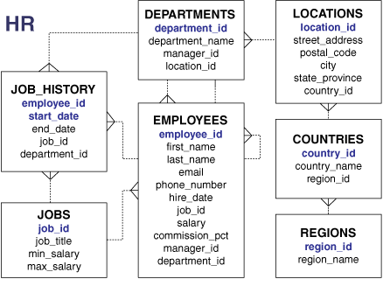

## **Lab Work:**

1. We can insert into a table values through a subquery as in

create table sales_reps(id number primary key, name varchar2(25), salary number(8,2), commission_pct number(2,2));

INSERT INTO sales_reps(id, name, salary, commission_pct)

SELECT employee_id, last_name, salary, commission_pct

FROM employees

WHERE job_id LIKE '%REP%';

1. Update employee 114’s job and salary to match that of employee 205.

UPDATE employees

SET job_id = (SELECT job_id

FROM employees

WHERE employee_id = 205),

salary = (SELECT salary

FROM employees

WHERE employee_id = 205)

WHERE employee_id = 114;

1. To create a copy of the employees tablecreate table copy_emp as

select * from employees;

1. Updates the COPY_EMP table by changing the department number of all employees with employee 200’s job ID to employee 100’s current department number.

UPDATE copy_emp

SET department_id = (SELECT department_id

FROM employees

WHERE employee_id = 100)

WHERE job_id = (SELECT job_id

FROM employees

WHERE employee_id = 200);

1. Delete the department of Payroll

DELETE FROM departments

WHERE department_name = 'Payroll';

1. To delete the whole table content

DELETE FROM copy_emp;

1. To delete based on a sub query. This command deletes all employees whose department name includes ‘Rec’.

DELETE FROM employees

WHERE department_id =

(SELECT department_id

FROM departments

WHERE department_name

LIKE '%Rec%');

1. To empty a table

TRUNCATE TABLE copy_emp;

1. We can update a specific record through insert as follows

INSERT INTO

(SELECT employee_id, last_name,

email, hire_date, job_id, salary,

department_id

FROM employees

WHERE department_id = 50)

VALUES (99999, 'Taylor', 'DTAYLOR',

TO_DATE ('07-JUN-99', 'DD-MON-RR'),

'ST_CLERK', 5000, 50);

1. After a DML command issued we can undo or confirm permanently the command by using rollback and commit

DELETE FROM employees

WHERE employee_id = 99999;

Rollback;

or

Commit;

1. Another example for commit

DELETE FROM departments

WHERE department_id IN (290, 300);

UPDATE employees

SET department_id = 80

WHERE employee_id = 206;

COMMIT;

1. We can insert a save point to be used for commit or rollback

Savepoint step_10;

## **Class Exercise:**

1. Create the table my_employee



1. Create an INSERT statement to add the first row of data to the MY_EMPLOYEE table from the following sample data. Do not list the columns in the INSERT clause.

ID LAST_NAME FIRST_NAME USERID SALARY

1- Patel Ralph rpatel 895

1. Dancs Betty bdancs 860

3- Biri Ben bbiri 1100

4- Newman Chad cnewman 750

5- Ropeburn Audrey aropebur 1550

1. Populate the MY_EMPLOYEE table with the second row of sample data from the preceding list. This time, list the columns explicitly in the INSERT clause.
2. Confirm your addition to the table.
3. Make the data additions permanent.
4. Change the last name of employee 3 to Drexler.
5. Change the salary to $1,000 for all employees with a salary less than $900.
6. Verify your changes to the table.
7. Create a save point.
8. Delete Betty Dancs from the MY_EMPLOYEE table.
9. Undo the command till the last save point.